Low Level Design

**Google App store Dataset**

|  |  |
| --- | --- |
| **Written By** | Mangesh Yadav |
| **Document Version** | 0.1 |
| **Last Revised Date** |  |

**Google App store Dataset**

# DOCUMENT CONTROL

**Change Record:**

|  |  |  |  |
| --- | --- | --- | --- |
| **VERSION** | **DATE** | **AUTHOR** | **COMMENTS** |
| 0.1 | 17-sep-2023 | Mangesh Yadav | Introduction and architecture defined |
|  |  |  |  |
|  |  |  |  |
|  |  |  |  |

**Reviews:**

|  |  |  |  |  |  |  |  |  |
| --- | --- | --- | --- | --- | --- | --- | --- | --- |
| **VERSION** | **DATE** |  | **REVIEWER** |  |  | **COMMENTS** | |  |
|  |  |  |  |  |  |  | |  |
| **Approval Status:** | |  |  |  | |  | |  |
| **VERSION** | **REVIEW DATE** |  | **REVIEWED BY** |  | | **APPROVED BY** |  | **COMMENTS** |
|  |  |  | |  | |  |  | |

**Contents**

1. **Introduction ................................................................................................................. 04** 
   1. **What is Low-Level Design Document? ............................................................04**

* 1. **Scope ................................................................................................................ 04**

1. **Architecture .................................................................................................................. 04**
2. **Architecture Description .............................................................................................. 05**

* 1. **Data Description ............................................................................................... 05**

## 3.2 Data Scrapping ................................................................................................. 05 3.3 Data Transformation ........................................................................................ 05 3.4 Data insertion into database ........................................................................... 05 3.5 Connection with SQL server ............................................................................ 06 3.5 Export Data from database .............................................................................. 07

**Google App store Dataset**

1. **Introduction**

**1.1 What is Low-Level design document?**

The goal of the LDD or Low-level design document (LLDD) is to give the internal logic design of the actual program code for the House Price Prediction dashboard. LDD describes the class diagrams with the methods and relations between classes and programs specs. It describes the modules so that the programmer can directly code the program from the document.

## 1.2 Scope

Low-level design (LLD) is a component-level design process that follows a step-by-step refinement process. The process can be used for designing data structures, required software architecture, source code and ultimately, performance algorithms. Overall, the data organization may be defined during requirement analysis and then refined during data design work.

1. **Architecture.**

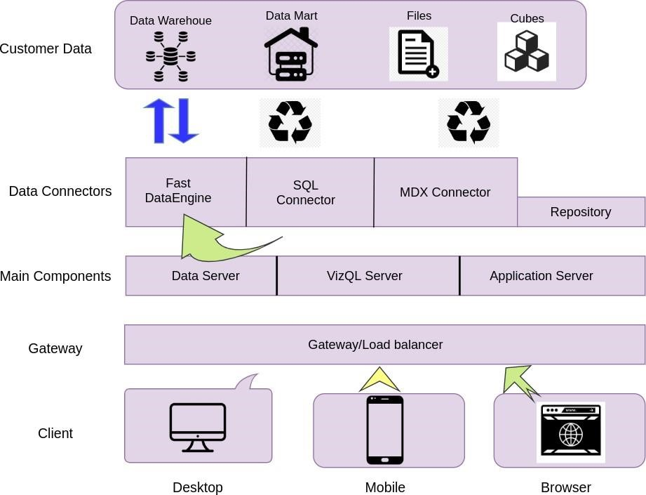

1. **Architecture Description**

## 3.1 Data Description

The Dataset contains information’s about 10000+ android application present in the google app store. The information contains such as category, rating, reviews, size, installs, type, content rating, genres etc.

1. Category: App category such as art & design, beauty, business, comics, finance, events, shopping, weather etc.

1. Rating: Rating ranging between 1 to 5 given by the users according to their experience about app.

1. Reviews: No of reviews given by users.

1. Size of the app in MB or KB.

1. Installs: No of installs done by the user for a particular app.

1. Type: Type of app such as free or paid.

1. Genre: genre category of app such as sports, tools, lifestyle, shopping, dating etc.

## 3.2 Web Scrapping

Web scraping is a technique to automatically extract content and data from websites using bots. It is also known as web data extraction or web harvesting. Web scrapping is made simple now days, many tools are used for web scrapping. Some of python libraries used for web scrapping are Beautiful Soup, Scrapy, Selenium, etc.

## 3.3 Data Transformation

In the Transformation Process, we will convert our original datasets with other necessary attributes format. And will merge it with the Scrapped dataset. For this purpose we used Python libraries such as Pandas and Numpy to clean and transform the data.

## 3.4 Data Insertion into Database

A. Database Creation and connection - Create a database with name passed. If the database is already created, open the connection to the database. B. Table creation in the database.

C. Insertion of files in the table

## 3.5 Make the SQL connection and set up the data source

**Step 1: Configuring Python.**

Python is a high-level, general-purpose, and very popular programming language. Basically, it was designed with an emphasis on code readability, and programmers can express their concepts in fewer lines of code.

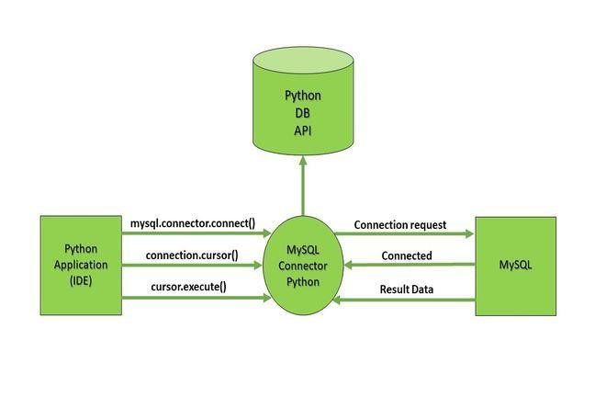

To create a connection between the MySQL database and python, the connect () method of MySQL. Connector module is used. We pass the database details like Hostname, username, and the password in the method call, and then method returns the connection object**.**

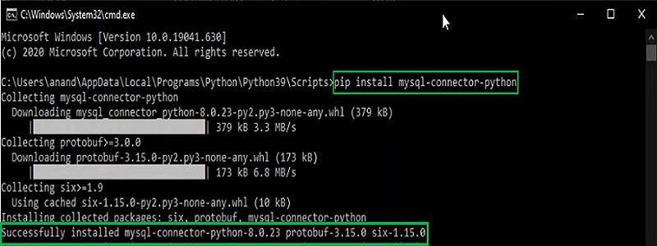

Following code to connect Python with MySQL.

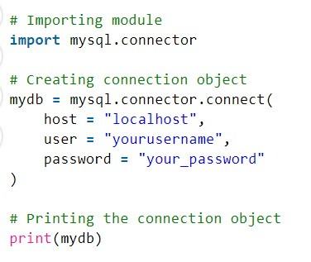

Output:

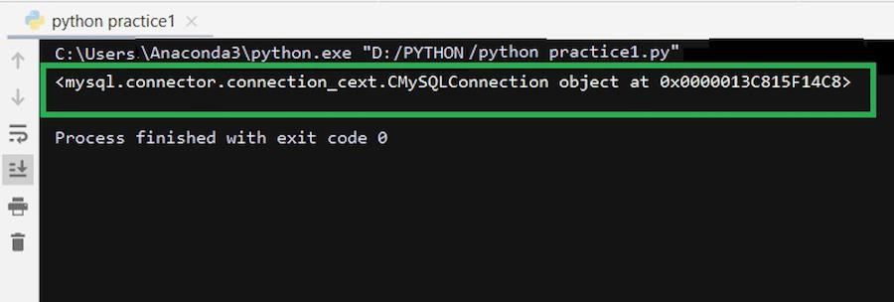

## 3.7 Export Data from Database

Data Export from Database - The data in a stored database is exported as a CSV file to be used for Data Preprocessing